**Deactivating Particle System Emission**

**Objective:** We’re going to keep the lasers that already in route from disappearing after we stop firing.

1. If you click on your Laser Left or Right GameObject you can see that we don’t want to turn the whole GameObject off. We want to turn off **Emission**.

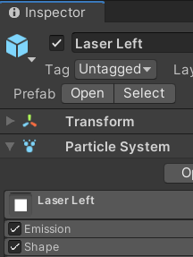

1. Open the **PlayerController.cs** script and go to line 80 to the **DeactivateLasers** method.
2. Lets delete everything inside the foreach loop and rework it

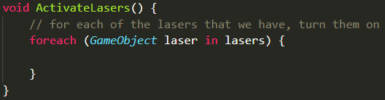

1. Lets create a variable. Since we’re not sure exactly what type we want it to be we can use **var** as a placeholder. Lets name it **emissionModule.**

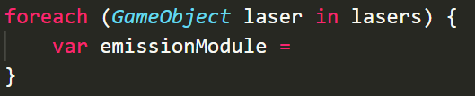

1. So for each laser we want to access its Particle System and within that we want to get the emission.



1. After that line we want to enable the Emissions

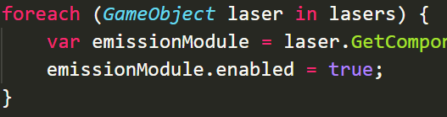

1. Copy this new code down to **DeactivateLasers** except change the **true** to **false**

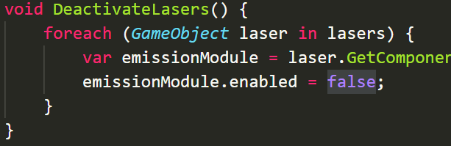

1. Go to Unity and Play test your changes
2. Now we know this code its too similar and that there has to be a way to refactor it. The only real difference is the true/false. Is there a way we can pass in this boolean?
3. Go to **ProcessFiring**. What if instead of calling **ActivateLasers** we rename it to **SetLasersActive** and pass **true** as an argument.

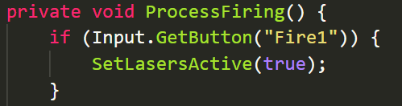

1. Lets replace the **DeactivateLasers** call with the same method (**SetLasersActive**) but instead pass **false**

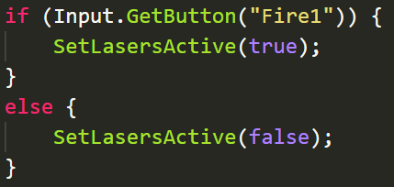

1. Delete the **DeactivateLasers** method
2. In the SetLasersActive definition we need to accept a bool parameter



1. And finally in our foreach lets replace the true with the argument.



1. Go to Unity and Play test your changes